Nanopore sequencing provides superior MGMT promoter methylation evaluation to conventional techniques

Skarphedinn Halldorsson *1, Richard Nagymihaly1, Areeba Patel 2, Petter Brandal3,

Ioannis Panagopoulos3, Henning Leske [4](https://orcid.org/0000-0002-3057-8730), Marius Lund-Iversen4, Felix Sahm 2, and Einar O. Vik-Mo  †1,5

1Vilhelm Magnus Laboratory, Institute for Surgical Research/Department of Neurosurgery Oslo University Hospital, Oslo, Norway

2Department of Neuropathology, University Hospital Heidelberg, Heidelberg, Germany 3Section for Cancer Cytogenetics, Institute for Cancer Genetics and Informatics, Oslo University Hospital 4Department of Pathology, Oslo University Hospital, Oslo, Norway 5Institute for Clinical Medicine, University of Oslo.

# Abstract

**Rationale:** Resistance of glioblastoma to the alkylating agent temozolomide may result from the expression of the DNA repair protein O6-methylguanine-DNA methyltransferase (*MGMT*). Methylation of the *MGMT* promoter region has been correlated with responsiveness to temozolomide, but there is no consensus on the most accurate method to determine this methylation. Conventional methods have limitations due to the dependence on bisulphate treatment and limited read length. Nanopore long-read sequencing offers methylation analysis of native DNA without the need for bisulphate treatment or amplification. Combined with recent advancements in targeting methods, nanopore sequencing can provide an accurate, broad and cost-effective approach to *MGMT* promoter methylation analysis.

**Methods:** We analyzed biopsies from148 patients operated for CNS tumors using Nanopore sequencing and compared the results to data obtained using pyrosequencing or methylation bead arrays. Isolated DNA was analyzed on the Oxford Nanopore Technologies (ONT) MinION flow cells following a CRISPR/Cas9 protocol and compared to results from adaptive sequencing runs on the same system. We then compared the methylation data to results from standard pyrosequencing diagnostic methods.

**Results:** We found a 92% correlation between pyrosequencing of 4 CpGs in the CpG island of MGMT and nanopore sequencing. Further, we could re-create classification by the MGMT STP27 algorithm with data from nanopore sequencing. Furthermore, we were able to include in the analysis an additional 94 CpGs within the MGMT CpG island and 17 CpGs within the island shores. Data clustering revealed a robust difference between unmethylated and methylated samples that could be used for patient stratification.

**Discussion:** Our findings demonstrate that ONT could replase pyrosequencing or methylation bead-array, providing high-confidence results within a few hours of sequencing while allowing for single or multiplex runs. The extension of the analysis to all of the 98 CpGs of the CpG island of the MGMT promoter region results in a complete picture of the investigated MGMT region, which potentially enables further exploration of the correlation between methylation status and additional clinical parameters. However, for full replacement of standard diagnostic methods such as pyrosequencing analysis, further studies need to be performed using nanopore sequencing to refine the treatment relevant sites and cut-off levels for methylation.

**Keywords:** MGMT promoter methylation, Nanopore sequencing, CRISPR/Cas9, Glioblastoma

# Introduction

Glioblastoma multiforme (GBM) is the most common and most aggressive type of primary malignant brain tumor in adults [Ostrom et al., 2020] with a median survival of about 15 years [Stupp et al., 2017]. Standard treatment for GBM involves surgical resection of the tumor followed by a combination of radiation and chemotherapy. Temozolomide (TMZ) is a chemotherapy drug that has been shown to improve the outcome in a subset of GBM patients when used in combination with radiotherapy [Stupp et al., 2009]. It is an alkylating agent that induces DNA damage by methylation of O-6 guanidine residues in dividing cells, leading to DNA damage and apoptosis [Zhang et al., 2011]. Despite its potential benefits, TMZ can cause a range of side effects and should therefore be limited to patients that may benefit from it and withheld from patients that most likely will only experience the side effects without any improvement in survival [Hegi and Ichimura, 2021]. The effects of TMZ are countered by the DNA repair protein O-6 methylguanine DNA methyltransferase (MGMT). MGMT expression is regulated via methylation of the promoter region [Nakagawachi et al., 2003]. The presence of MGMT promoter methylation has been associated with increased survival in glioblastoma patients treated with temozolomide and radiation therapy [Hegi et al., 2019]. Methylation of the MGMT promoter is believed to silence its expression, thereby increasing sensitivity of GBM tumor cells to TMZ. MGMT promoter methylation status is therefore an important factor for the management and treatment of GBM [Christmann et al., 2011].

Pyrosequencing is a commonly used method to detect MGMT promoter methylation in clinical samples. The Qiagen® MGMT pyrosequencing kit, which detects methylation on 4 CpG sites (76-79) on the MGMT promoter CpG island, is a common choice in the clinical setting. However, there is neither a clear consensus on the best cut-off point to classify clinically relevant methylated or unmethylated samples, nor which method should be used [Brandner et al., 2021]. Standard diagnostic techniques include methylation-specific PCR (MSP), pyrosequencing (PSQ) or methylation bead array [Johannessen et al., 2018]. All of these methods rely on bisulfite conversion of native tumor DNA prior to analysis and only include a fraction of the 98 potentially relevant CpG sites in the CpG island of MGMT [Malley et al., 2011]. In recent years, advances in sequencing technology have allowed for more sensitive and accurate detection of DNA methylation. Nanopore sequencing, which uses a nanopore-based sensor to detect changes in electrical current as nucleic acids (DNA or RNA) pass through the pore, has the ability to detect epigenetic modifications, such as methylation, directly from the signal [Jain et al., 2016]. Due to the long-read nature of nanopore sequencing, it also affords methylation analysis of far longer sequences than either MSP or pyrosequencing. Consequently, nanopore sequencing offers an overview of the methylation status of all CpGs of the MGMT CpG-island including the promoter region, using native genomic DNA without bisulfite conversion, which can be both time and cost efficient in a clinical setting [Laver et al., 2015]. In this study, we compared the results of nanopore sequencing of the promoter region of MGMT of 148 central nervous system (CNS) tumors, including 91 GBMs, with results obtained from standard diagnostic methods comprising pyrosequencing or Illumina 850K bead array.

# Materials and Methods

## Patients and samples

Samples from three independent cohorts were included into this study; 1) Retrospective analysis of DNA from 68 CNS tumor samples provided by the Institute for Cancer Genetics and Informatics, Oslo University Hospital, screened for MGMT promoter methylation using the Qiagen® MGMT pyrosequencing kit (MGMT pyro kit). These samples are referred to as ”Retrospective” in the study. 2) Retrospective analysis of 67 sequences generated as part of the Rapid-CNS adaptive sampling pipeline [Patel et al., 2022] analysed by Illumina® methylation 850K bead array. These samples are referred to as ”Rapid-CNS” in the study. 3) DNA extracted from 16 glioma biopsies that were operated at Oslo University Hospital. A separate biopsy derived from paraffin-embedded tissue was analysed with the Qiagen® MGMT pyrosequencing kit at the Dept of Molecular Pathology. These samples are refered to as ”Prospective” in the study. Table 1 provides an overview of all samples used in this study.

In total, 153 samples from 148 patients were analyzed for MGMT promoter methylation, consisting of 91 GBM samples, 23 IDH-glioma samples, and 12 meningioma samples (Supplementary Figure 1a). Two methods were used to enrich for the region of interest: CRISPR/Cas9 targeted sequencing of the MGMT promoter region [Wongsurawat et al., 2020] and adaptive sampling. Cas9 targeted sequencing was applied to 86 samples, 46 of which were run as single samples and 40 that were run as multiplexed groups of five. 67 samples were analyzed as part of an adaptive sampling pipeline.

## Sample preparation and Nanopore sequencing

Between 10 and 25 mg of fresh/frozen tissue were used to extract genomic DNA (Merck’s GenElute™ Mammalian Genomic DNA Miniprep kit) following the manufacturer’s protocol. Purity and concentration of DNA samples was determined using NanoDrop™ One and Qubit™ 4 Fluorometers (Thermo Fischer Scientific). Isolated DNA was stored at -20°C until analysis. Cas9 mediated targeted sequencing was performed with the Cas9 Sequencing Kit (Oxford Nanopore Technologies) according to the manufacturers protocol (version ENR 9084 v109 revR 04Dec2018). Briefly, Cas9 ribonucleoprotein complexes (RNPs) were created by mixing equimolar concentrations (100 µM) of crispr RNA (crRNA) and trans-activating elements (tracrRNA) to HiFi Cas9 enzyme (IDT). Dephosphorylated gDNA (2-5 µg) was cleaved and dA-tailed with Cas9 RNPs and Taq polymerase. Finally, sequencing adaptors were ligated to the cleaved fragments and the final DNA library was purified with AMPure XP beads (Beckman Coulter). Barcodes were applied to a number of samples to allow multiplexing of five samples based on an experimental protocol from Oxford Nanopore Technologies. Purified DNA libraries were loaded onto R9.4.1. flow cells on MinION Mk1B or Mk1C devices and sequenced for 4-24 hours. Individual flow cells were flushed and re-used up to four times for single samples and twice for multiplexed samples. A minimum pore-count of 300 was deemed sufficient for a single sample, 800 for multiplexed samples. Raw fast5 sequences of all fragments mapping to the MGMT promoter in the Rapid-CNS data were provided for re-analysis.

## Primers

All primers were purchased from Integrated DNA Technologies, IDT (Leuven, Belgium). Previously published primers were initially used to target the MGMT promoter [Wongsurawat et al., 2020], termed MGMT-left-1 (ATGAGGGGCCCACTAATTGA) and MGMT-right-1 (ACCTGAGTATAGCTCCGTAC), which yielded produced a fragment of 2,522 bp. In order to increase cas9 efficiency and expand the size of the fragment, we added additional crRNA primers: MGMT-left-2 (GCCAACCACGTTAGAGACAATGG), MGMT-right-2 (GTACGGAGCTATACTCAGGT), MGMT-right3 (CTGGAATCGCATTCCAGTAGTGG) and MGMT-right-4 (ACTTCGCAAGCATCACAGGTAGG) providing a fragment of 4,800 bp.

## Data analysis

Raw sequences were base-called, methylation called and mapped (hg19, chromosome 10) using the Megalodon toolbox (version 2.5.0 built on guppy version 6.2.7) from Oxford Nanopore Technologies (https://github.com/nanoporetech/megalodon). Methylation percentages of individual CpG sites were compiled using custom scripts in R. All statistical analyses were performed in R (version 4.2.1). The source code and data to reproduce all analyses and figures from this manuscript is available at https://github.com/SkabbiVML/MGMT_R.

# Results

## Data acquisition

Sequence depth of the MGMT promoter region in the samples varied based on method, sequencing time, and DNA and flow-cell quality. Single sample runs produced on average more sequences in the region of interest (mean = 92.1, median = 33) than barcoded runs (mean = 17.2, median = 12) and adaptive sampling (mean = 18.7, median = 15) (Supplementary **Figure 1**). No bias in sequencing depth was observed between methylated and unmethylated samples across Cas9 targeted samples, either single or multiplexed. However, a slight but statistically significant difference in sequence depth was observed between methylated (mean = 23.6, median = 21) and unmethylated (mean = 16.5, median = 15) samples evaluated by adaptive sampling (p=0.021).

## Nanopore Sequencing versus Pyrosequencing of the MGMT Promoter

A subset of samples (retrospective cohort, n=68) was analyzed using the Qiagen® MGMT pyrosequencing kit (MGMT pyro kit)), which specifically measures methylation on CpGs 76-79 of the MGMT CpG island. To directly compare the results of nanopore sequencing and MGMT pyro kit, we extracted the methylation results for CpGs 74-79 from the nanopore data and compared them to the methylation values obtained by the MGMT Pyro kit (Figure 2). Correlation between the methylation values of each overlapping CpG site between nanopore and pyrosequencing ranged from 0.78 to 0.88 (Figure 2a). However, results from the MGMT pyro kit are typically returned as an average methylation percentage of all four CpG sites. When results of nanopore sequencing and the MGMT pyro kit are averaged across the four CpG sites the correlation increased to 0.92 (Figure 2b).

At Oslo University Hospital, an average methylation of 10% and above using the MGMT pyro kit is demonstrated to stratify patients’ survival [Johannessen et al., 2018, Håvik et al., 2012]. To compare classification results of nanopore sequencing and the MGMT pyro kit, a 10% average methylation threshold of CpGs 76-79 was applied to the nanopore data to re-classify MGMT methylated versus unmethylated samples (Figure 2c). A 91% concordance rate was observed between the two methods (62 out of 68 samples) (Figure 2d). Notably, discordant results between nanopore sequencing and the MGMT pyro kit were in all cases classified as methylated by nanopore sequencing but unmethylated by pyrosequencing. Of importance is that for these samples the pyro- and sequencing were based on formalin-fixed and frozen tissue, accordingly.

## Nanopore sequencing versus STP27 and cumulative number of methylated CpG sites

Illumina® Human Methylation BeadChips (HM-27K, HM-450K, and HM-850K) are microarray-based platforms used to investigate DNA methylation patterns in human tumor samples. Despite detecting the methylation status of tens to hundreds of thousands of CpG sites, these platforms only cover a fraction of the approximately 30 million CpG sites in the human genome. To predict the clinically relevant methylation status of the MGMT promoter, a regression model called *MGMT STP-27* has been developed. This model uses the methylation status of two array probes, cg12434587 (CpG 31) and cg12981137 (CpG84), as reported by *Bady et al.* [Bady et al., 2012, Bady et al., 2016].

The samples of the Rapid-CNS study (n=67) were analyzed by Illumina® HM-850K EPIC array in addition to nanopore sequencing and ground truth methylation status derived from the STP-27 classifier. In order to compare nanopore sequencing results to the MGMT STP-27 classifier results, the two CpG sites represented in the MGMT STP-27 algorithm were extracted from the methylation percentage values plotted against each other (Figure 3a). Methylated and unmethylated samples of the Rapid-CNS cohort could be separated with 95% accuracy (64 of 67) by an average methylation threshold of 12,5% of CpGs 31 and 84 (Figure 3b and c).

Both the MGMTR pyro kit and the MGMT STP-27 approach are based on a very limited number of CpG sites to infer the clinically relevant methylation status of the whole MGMT promoter region. Recently, Siller et al. proposed a method for GBM patient stratification by counting the methylation of the 25 CpG sites of the second differentially methylated region (DMR2) in the CpG island of MGMT using Sanger bisulfite sequencing [Siller et al., 2021]. To re-classify the retrospective and Rapid-CNS samples according to the Siller et al. criteria, the results of nanopore sequencing were binarized by applying a methylation cut-off of 10% to each CpG site and summarized the counts in DMR2. A nearly complete separation of methylated and unmethylated samples was observed when a cut-off threshold of ≥ 15 methylated CpG sites was applied (Figure 4a). Finally, we examined if average methylation of all CpG sites within the MGMT promoter CpG island could re-classify the samples according to their ground truth (Figure 4b). [TO BE REPLACED WITH PATEL ET AL MGMT REGRESSION MODEL]

## Unsupervised clustering of samples based on nanopore sequencing

Although classification by bisulphite sequencing methods can be recreated to a reasonable degree with nanopore sequencing data, this does not take advantage of other CpG sites within the designated MGMT promoter CpG island or its shelves and shores that may prove to be relevant for MGMT gene expression. To investigate the impact of methylation at CpG sites not covered by above methods, we performed hierarchical clustering of 98 CpG sites on the CpG island and included 7 CpGs upstream and 11 CpGs downstream of the CpG island. Unsupervised hierarchical clustering using Ward’s method reveals two main clusters that largely correspond to the classification into methylated and unmethylated samples by pyrosequencing or methylation bead array (Figure 5a).

Unmethylated samples exhibit low methylation levels throughout the CpG island, except for the first 5 CpG sites, which are often methylated. On the other hand, methylated samples show a larger gradient of methylation, with higher levels towards either end of the CpG island. This is further supported by the average methylation percentage of each CpG site in methylated and unmethylated samples (Figure 5b), which reveals the biggest differences in methylation occur in CpGs 6 through 15 and 71 through 90. Welch’s two sided t-tests between methylated and unmethylated samples were performed at every CpG site and the results adjusted for multiple testing (Bonferroni method). Figure 5c shows the adjusted p-values for every site in the MGMT CpG island and it’s upstream and downstream shores. Interestingly, the lowest p-values are observed at CpG sites 3 through 13 (excluding CpG 6) which far upstream of DMR2.

Unsupervised hierarchical clustering places five samples previously classified as methylated with the otherwise unmethylated samples and one unmethylated sample with methylated samples. This pattern of separation is also evident when unsupervised clustering is performed on GBM samples only (Figure 6a).

In addition to the robust separation of samples into clusters that largely correspond to the predetermined methylation status, k-means clustering showed separation of samples in the methylated cluster (Figure 6b). Of the 22 samples that cluster with methylated samples, 9 samples fall within what can be described as ”very high methylation” cluster. The functional significance of these clusters remains to be determined.

## Survival Analysis

While nanopore methylation profiles were often in agreement with bisulphite sequencing methods, discrepancies were also observed (Figure 5a). Therefore, we investigated whether clustering by nanopore sequencing was as effective as the MGMT-pyro kit or EPIC-array for survival prediction. We conducted cas9-targeted nanopore sequencing on 16 additional samples that were simultaneously analyzed by pyrosequencing. In total, we performed survival analysis on 25 GBM, IDHwt patients (11 females, average age 58.4 years and 14 males, average age 62.7 years) receiving surgery followed by radiotherapy combined with concomitant and adjuvant temozolomide where biopsies were classified by both MGMT-pyro kit and cas9-targeted nanopore sequencing (Table 3). As expected, Kaplan-Meier survival analysis of patients based on pyrosequencing showed a significantly longer overall survival in patients classified as methylated by pyrosequencing (Figure 7a, p=0.0078). Notably, when patients were classified according to unsupervised clustering by nanopore sequencing (Figure 7b), a larger dissociation of the survival curves with significantly longer survival was observed in patients classified as methylated based upon nanopore sequencing (p=0.039). Although the sample size is small, our results suggest that classifying patients via nanopore sequencing is equally reliable as classification with the MGMT-pyro kit.

# Discussion

In this study we analyzed 145 CNS tumors using targeted nanopore sequencing and compared the results to those acquired by pyrosequencing and methylation bead arrays. We found a 92% correlation between pyrosequencing and nanopore sequencing, but note that samples with low methylation were sometimes overestimated with nanopore sequencing compared to pyrosequencing. Nanopore sequencing was also able to re-create the results of the MGMT STP-27 classifier or Sanger bisulfide sequencing. In addition, nanopore sequencing allowed for the analysis of an additional 94 CpGs in the MGMT promoter region and analysis can be extended both upstream and downstream of the designated CpG island. Unsupervised hierarchical clustering of samples based on nanopore methylation data including 115 CpGs in and adjacent to the MGMT promoter showed clear separation of methylated and unmethylated samples. Finally, we showed that classification of patients by targeted nanopore sequencing of the MGMT promoter yielded results that were comparable to pyrosequencing in Kaplan-Meier survival analysis. To the best of our knowledge, this is the first study to examine all 98 sites with the MGMT promoter CpG island, along with it’s shores in multiple patient biopsies by nanopore sequencing.

MGMT promoter methylation by nanopore sequencing has several advantages over conventional techniques. First, nanopore sequencing can detect epigenetic modifications on native DNA, thereby circumventing the need for bisulfite treatment. This saves time and reduces the potential risk of bias introduced by bisulfite treatment that has been shown to underrepresent densely hydroxymethylated (5hmC) regions [Huang et al., 2010]. This may partly explain the higher estimation of methylation by nanopore sequencing when compared to the MGMT pyro kit, particularly in low methylation samples (Figure 2). Secondly, the long-read nature of nanopore sequencing offers a complete overview of methylation in the MGMT promoter CpG island and can be extended in either direction to include the shores and shelves of the CpG island. Regions outside the DMR2 are neglected by most common assays but have been shown to discriminate the methylation status of GBMs [Tierling et al., 2022]. Third, the methodology of nanopore sequencing is flexible making it possible to run single samples or as multiplex analysis. The technology also allows for easy incorporation of other assays such as whole genome sequencing, exome sequencing, *in silico* enrichment (adaptive sampling) or cas9 targeted enrichment, either as single samples or multiplexed in addition to MGMT promotor methylation.

Ever since MGMT promoter methylation was discovered as a prognostic marker for over-all and progression-free survival in GBM [Hegi et al., 2005], there has been an ongoing debate regarding the optimal method and optimal cut-off to determine clinically significant methylation of the MGMT promoter Table 2. Methylation-specific PCR, pyrosequencing and methylation bead arrays are commonly used but when these methods have been directly compared, results have been discordant in up to a third of cases [Tierling et al., 2022, Håvik et al., 2012, Johannessen et al., 2018]. This is likely due to lack of standardization between CpG sites queried by different methods and different cut-offs applied. A recent meta-analysis including 32 cohorts and 3474 patients could not draw strong conclusions of the optimal CpG sites to query and optimal cut-off to apply [Brandner et al., 2021]. The results presented here demonstrate that nanopore sequencing of the MGMT promoter region can largely recreate the results of conventional bisulfite dependant methods (**??**).

Unsupervised hierarchical clustering of glioblastoma samples based on nanopore sequencing indicates the presence of one or more sub-groups within the previously defined methylated samples. These groups are defined both by extent and amount of methylation Figure 6a.

We conclude that nanopore sequencing of the MGMT promoter region performs as well or better than standard methods such as pyrosequencing. This is true for both cas9 targeted sequencing of the MGMT promoter and inclusion of the MGMT promoter into an adaptive sequencing panel. Distinct subgroups within both methylated and unmethylated samples were observed via nanopore sequencing although any difference in patient outcome between these clusters has yet to be determined.

# Tables

Table 1: Summary of samples included in this study.

|  |  |  |  |  |
| --- | --- | --- | --- | --- |
|  | **DenStem** | **Radium** | **Rapid-CNS** | **Total** |
| **Astrocytoma** | 3 | 1 | 3 | 7 |
| **Astrocytoma HG** | 0 | 4 | 4 | 8 |
| **Pilocytic astrocytoma** | 0 | 0 | 4 | 4 |
| **Glioblastoma** | 13 | 29 | 49 | 91 |
| **Meningioma** | 0 | 12 | 0 | 12 |
| **Metastasis** | 0 | 7 | 0 | 7 |
| **Oligodendroglioma** | 0 | 2 | 6 | 8 |
| **Other** | 0 | 10 | 1 | 11 |

**Total** 16 65 67 148

Table 2: Summary of reported optimal cut-offs for determining methylated versus unmethylated samples

12

|  |  |  |  |  |  |  |  |  |
| --- | --- | --- | --- | --- | --- | --- | --- | --- |
| Author Year Method Patients CpGs Optimal cut-off Comment Reference | | | | | | | | |
| Hegi | 2019 | qMSP | 4041 |  | >1.27 | ”Grey-zone” patients benefit from TMZ | [Hegi et al., 2019] |
| Johannessen | 2018 | qMSP, PSQ | 48 |  | 7 % | PSQ gives better results than other methods | [Johannessen et al., 2018] |
| Nguyen | 2021 | PSQ | 109 |  | 21 % | Higher methylation corrilates with longer OS | [Nguyen et al., 2021] |
| Quillien | 2012 | MSP, PSQ, MS-HRM | 100 | 5 | 8 % | PSQ performs best | [Quillien et al., 2012] |
| Xie | 2015 | PSQ | 43 |  | 10 % | Not testing cut-off | [Xie et al., 2015] |
| Yuan | 2017 | PSQ | 84 | 4 | 12.50 % | Higher methylation corrilates with longer OS | [Yuan et al., 2017] |
| Brigliadori | 2016 | PSQ | 105 | 10 | 30 % | ”Grey-zone” patients do not benefit from TMZ | [Brigliadori et al., 2016] |
| Radke | 2019 | PSQ, sqMSP | 111 |  | 10 % | Best results when PSQ and MSP were combined | [Radke et al., 2019] |
| Chai | 2021 | PSQ | 173 | 4 | 10 % | MGMT promoter methylation has predictive value in IDH-mutant glioblastoma | [Choi et al., 2021] |
| Dovek | 2019 | qMSP | 165 |  | >1 | ”Grey-zone” patients benefit from TMZ, higher methylation does not correlate with longer OS | [Dovek et al., 2019] |
| Siller | 2021 | MSP, Sseq | 215 | 25 |  | Linear correlation between number of methylated CpG sites and OS | [Siller et al., 2021] |

Table 3: Patients used in survival analysis

**Sample ID Age Sex Diagnosis IDH Resection Treatment OS (months) Status Pyro_state NP cluster**

1701-2275 66 F GBM Neg GTR Stupp 14.99 Dead UnMethylated 1

1701-2430 78 M GBM Neg GTR Stupp 5.19 Dead Methylated 2

1701-2590 58 M GBM Neg STR Stupp 24.5 Dead Methylated 2

1701-2623 57 F GBM Neg STR Stupp 28.77 Dead Methylated 2

1701-2769 73 M GBM Neg STR Stupp 20.91 Dead UnMethylated 1

1701-2950 77 M GBM Neg STR Stupp 11.97 Dead UnMethylated 1

1501-1486 60 M GBM Neg GTR Stupp 29.26 Dead Methylated 2

1501-1757 65 M GBM Neg STR Stupp 29.69 Dead Methylated 2 1501-1858 62 F GBM Neg STR Stupp 6.9 Dead UnMethylated 1

1501-1880 64 M GBM Neg STR Stupp 25.48 Dead Methylated 2

1501-2159 58 M GBM Neg STR Stupp 21.6 Dead Methylated 2

13

1501-2348 58 M GBM Neg STR Stupp 11.44 Dead UnMethylated 1

1501-2391 72 F GBM Neg STR Stupp 21.21 Dead Methylated 2

1501-2425 58 F GBM Neg STR Stupp 13.61 Dead Methylated 2

1601-0227 66 M GBM Neg STR Stupp 21.96 Dead Methylated 2

1601-0353 51 M GBM Neg GTR Stupp 12.85 Dead Methylated 2

T20-061 64 F GBM Neg STR Stupp 8.3 Dead Methylated 1

T20-192 52 F GBM Neg STR Stupp 23 Dead Methylated 2

T21-173 66 F GBM Neg STR Stupp 13.6 Dead Methylated 2

T21-214 49 M GBM Neg GTR Stupp 9.4 Dead UnMethylated 1

T21-216 46 F GBM Neg GTR Stupp 14.31 Alive Methylated 2

T21-224 60 F GBM Neg GTR Stupp 14.08 Alive Methylated 1

T21-240 55 M GBM Neg GTR Stupp 15.16 Alive UnMethylated 2

T21-242 66 M GBM Neg GTR Stupp 14.47 Alive Methylated 2

T21-326 39 F GBM Neg GTR Stupp 13.78 Alive Methylated 1

# Figures

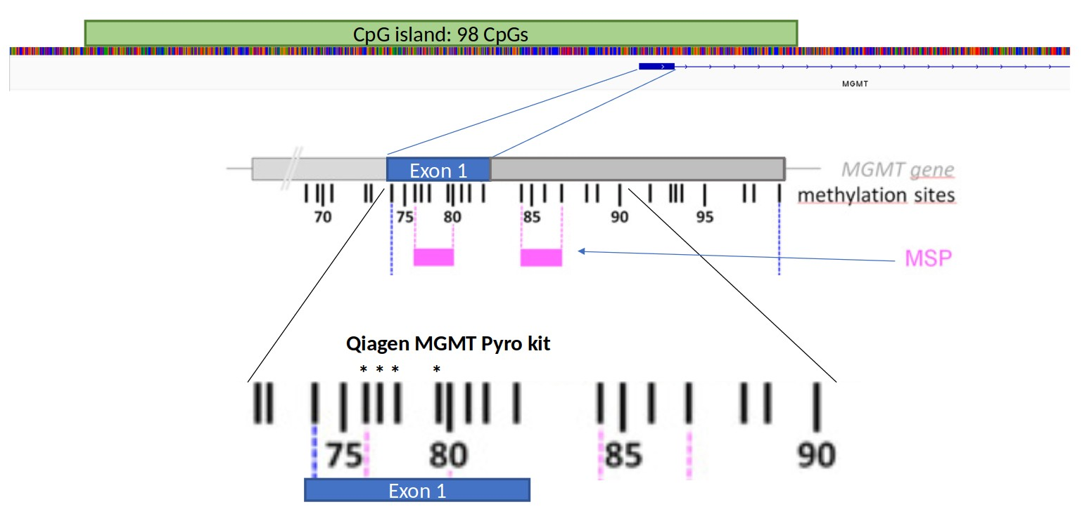

Figure 1: Organization of the MGMT promoter. MSP refers to the typical primer sites of methylation specific PCR to determine MGMT promoter methylation. Asterixes represent the 4 CpGs analysed by the Qiagen® MGMT pyrosequencing kit.

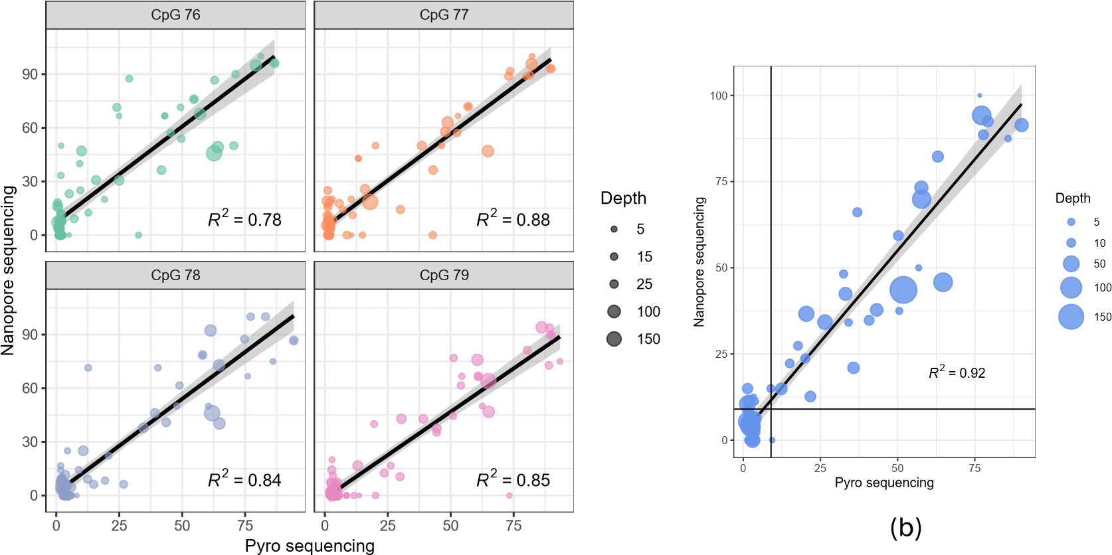

(a)

0

25

50

75

Methylated

UnMethylated

Nanopore methylation (%)

3

2

0

6

3

0

Radium

UnMethylated

Methylated

UnMethylated

Methylated

Known_status

Nanopore_status

Known methylation status (PSQ) (d)

(c)

Figure 2: Comparison of nanopore sequencing and Pyrosequencing kit of CpGs 76-79 in exon 1 of the MGMT promoter. Results show per-site methylation percentage of each CpG (a) or average values of the 4 CpG sites analysed by the MGMT Pyro kit. Black horizontal and vertical lines mark the 10 % cut-off value between methylated and unmethylated samples, as determined by pyrosequencing. c) Comparison of pyrosequencing classification into methylated versus unmethylated based on a 10% average methylation threshold of CpGs 76-79 in the MGMT promoter. The Y-axis represents average methylation percentage of the same four CpG sites based on nanopore sequencing. d) Confusion matrix showing the concordance of classification via MGMT pyro kit (known status) and classification by average methylation of CpGs 76-79 as determined by nanopore sequencing.

Rapid−CNS

0

25

50

75

CpG 84 (cg12981137)

Depth

5

15

30

Known Status

Methylated

UnMethylated

0

25

50

75

Methylated

UnMethylated

Average methylation %

of CpGs 31 and 84

44

1

2

20

Rapid−CNS

UnMethylated

Methylated

STP27 Nanopore

0 25 50 75 Known methylation status UnMethylated Methylated

CpG 31 (cg12434587) Known status

(b) (c)

(a)

Figure 3: Comparison of nanopore sequencing results for CpG sites 31 and 84 in the MGMT CpG island to the MGMT STP27 classifies. a) Methylation percentage of CpGs 31 and 84 for all samples in the Rapid-CNS cohort. Known status of these samples was derrived from the STP27 classifier. b) Average methylation of CpGs 31 and 84 plotted against the known methylation status. c) Confusion matrix showing concordance of STP27 classifier (known status), and classification based on average methylation of CpGs 31 and 84 as determined by nanopore sequencing.

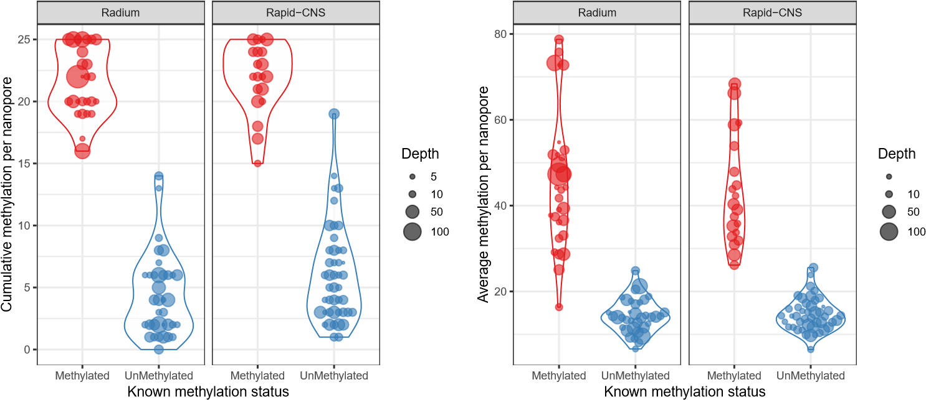5

(a) (b)

Figure 4: a) Comparison of cumulative methylation of the CpGs 74 -98 in the MGMT promoter region based on nanopore methylation and known status of samples. Method proposed by [Siller et al., 2021]. b). Comparison of average methylation percentage by nanopore sequencing of all CpG sites in the MGMT CpG island to known status. Known status of retrospectively analyzed samples derived by MGMT pyrosequencing kit, known status of ”Rapid-CNS” samples derived from methylation bead array (MGMT STP-27 classifier).

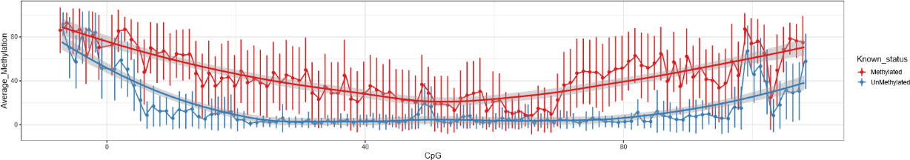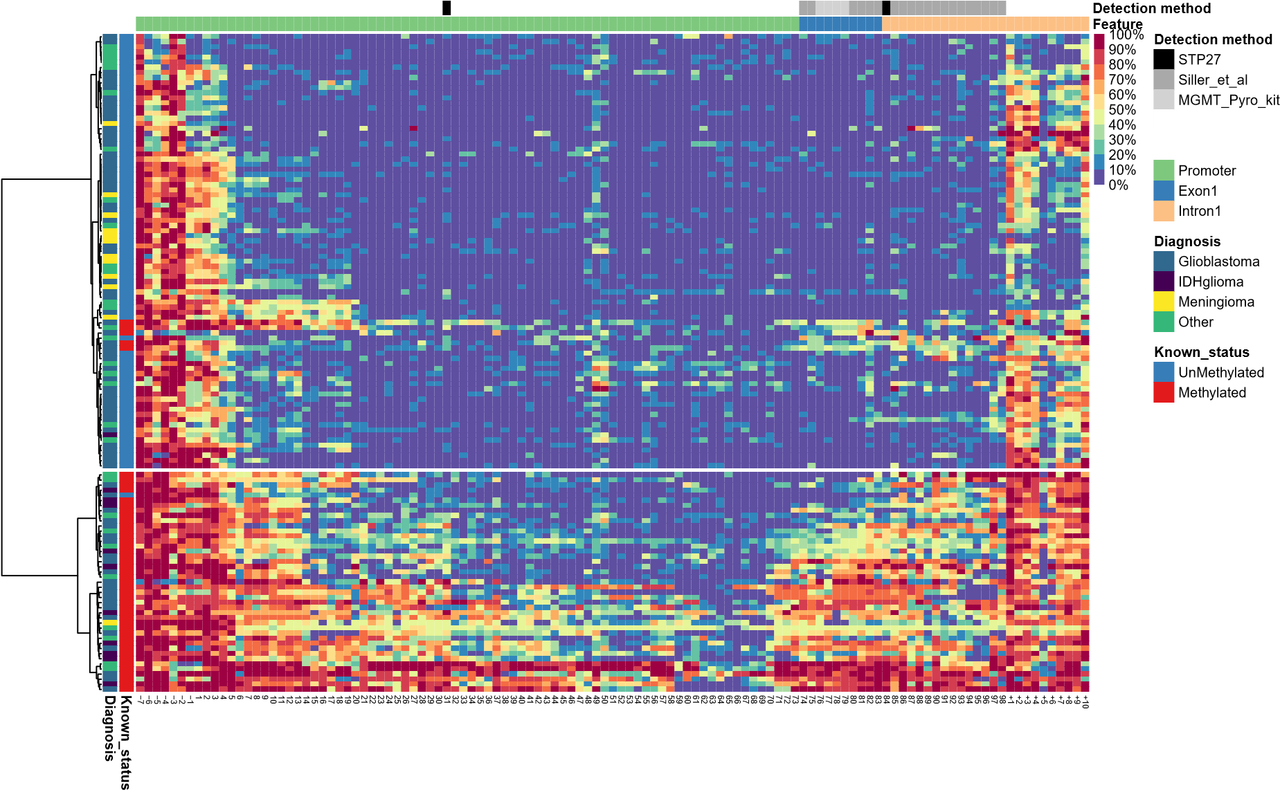a)

(b)

1e−20

1e−14

1e−08

1e−02

0

40

80

CpG

adj.p.val

(c)

Figure 5: a) Clustered heatmap of all samples based on nanopore sequencing of CpG island of the MGMT promoter. n = 128. b) Dotplot showing average methylation percentage of CpG sites in and around the MGMT promoter. Error bars represent standard deviation, grey areas show 95% confidence intervals of regression lines, n = 128. c) Dotplot showing Bonferroni adjusted p-values of Welch’s two-sided t-test for every CpG site. Horizontal line depicts 0.01.

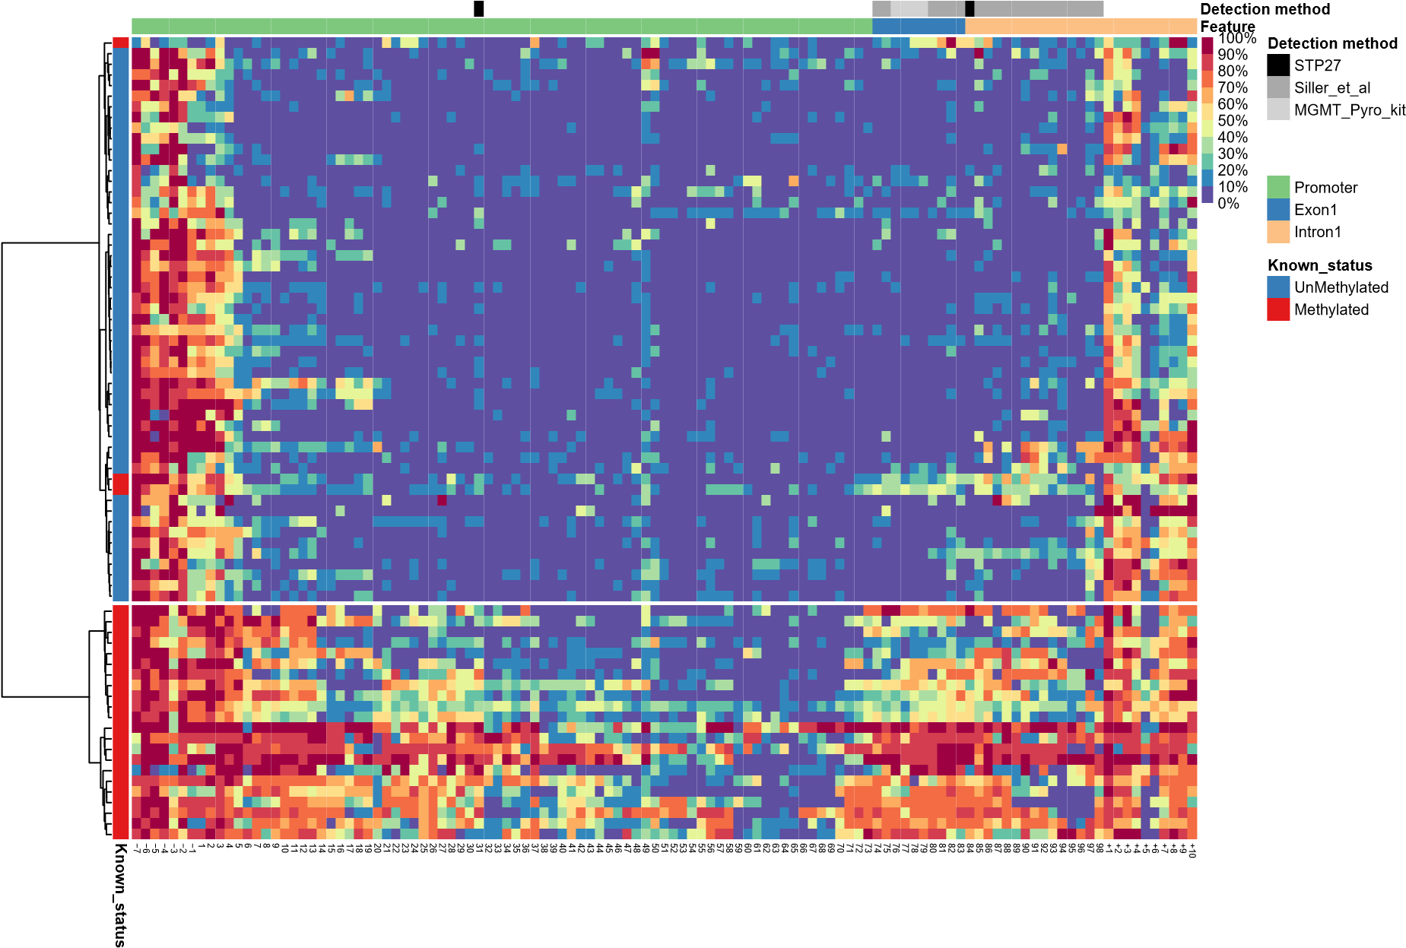

(a)

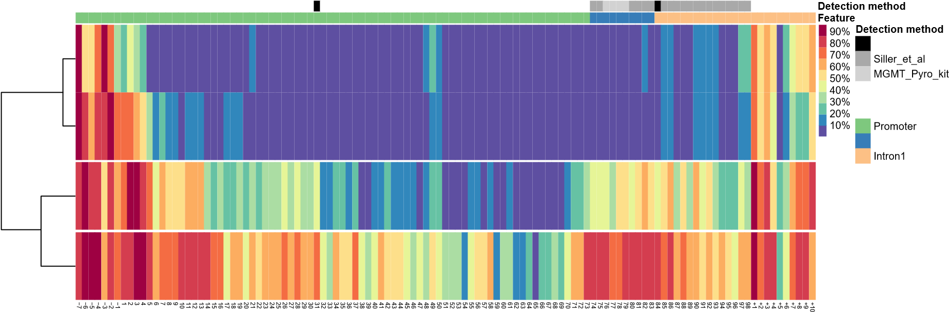STP27

**Feature**

Exon1

(b)

Figure 6: a) Heatmap showing unsupervised clustering of glioblastoma samples based on nanopore sequencing of the CpG island in the MGMT promoter. n = 78. b) K-means clustering of glioblastoma samples.

+

+

+

+

+

78

p = 0.00

0.00

0.25

0.50

0.75

1.00

0

10

20

30

**OS, Months**

**Survival probability**

Pyrosequencing

~~+~~

~~+~~

Methylated

UnMethylated

Number at risk

Pyrosequencing

18

1

6

9

9

4

0

7

5

2

1

0

0

10

Methylated

UnMethylated

5 15 20 25 30

OS, Months

(a) Pyro classification

+

+

+

+

+

p = 0.0039

0.00

0.25

0.50

0.75

1.00

0

10

20

30

**OS, Months**

**Survival probability**

Nanopore

~~+~~

~~+~~

Cluster 1

Cluster 2

Number at risk

Nanopore

9

6

1

1

0

0

16

15

10

9

4

0

10

15

Cluster1

Cluster2

5 20 25 30

OS, Months

(b) Nano Classification

Figure 7: Patient survival based on Pyrosequencing classification (a) or Nanopore Sequencing classification (b)

# References

[Bady et al., 2016] Bady, P., Delorenzi, M., and Hegi, M. E. (2016). Sensitivity Analysis of the

MGMT-STP27 Model and Impact of Genetic and Epigenetic Context to Predict the MGMT Methylation Status in Gliomas and Other Tumors. *Journal of Molecular Diagnostics*, 18(3).

[Bady et al., 2012] Bady, P., Sciuscio, D., Diserens, A. C., Bloch, J., Van Den Bent, M. J., Marosi,

C., Dietrich, P. Y., Weller, M., Mariani, L., Heppner, F. L., Mcdonald, D. R., Lacombe, D., Stupp, R., Delorenzi, M., and Hegi, M. E. (2012). MGMT methylation analysis of glioblastoma on the Infinium methylation BeadChip identifies two distinct CpG regions associated with gene silencing and outcome, yielding a prediction model for comparisons across datasets, tumor grades, and CIMP-status. *Acta neuropathologica*, 124(4):547–560.

[Brandner et al., 2021] Brandner, S., McAleenan, A., Kelly, C., Spiga, F., Cheng, H. Y., Dawson, S., Schmidt, L., Faulkner, C. L., Wragg, C., Jefferies, S., Higgins, J. P., and Kurian, K. M. (2021). MGMT promoter methylation testing to predict overall survival in people with glioblastoma treated with temozolomide: A comprehensive meta-analysis based on a Cochrane Systematic Review. *Neuro-Oncology*, 23(9):1457–1469.

[Brigliadori et al., 2016] Brigliadori, G., Foca, F., Dall’Agata, M., Rengucci, C., Melegari, E., Cerasoli, S., Amadori, D., Calistri, D., and Faedi, M. (2016). Defining the cutoff value of MGMT gene promoter methylation and its predictive capacity in glioblastoma. *Journal of Neuro-Oncology*, 128(2).

[Choi et al., 2021] Choi, H. J., Choi, S. H., You, S. H., Yoo, R. E., Kang, K. M., Yun, T. J., Kim, J. H., Sohn, C. H., Park, C. K., and Park, S. H. (2021). MGMT promoter methylation status in initial and recurrent glioblastoma: Correlation study with DWI and DSC PWI features. *American Journal of Neuroradiology*, 42(5).

[Christmann et al., 2011] Christmann, M., Verbeek, B., Roos, W. P., and Kaina, B. (2011). O6Methylguanine-DNA methyltransferase (MGMT) in normal tissues and tumors: Enzyme activity, promoter methylation and immunohistochemistry. *Biochimica et Biophysica Acta (BBA) - Reviews on Cancer*, 1816(2):179–190.

[Dovek et al., 2019] Dovek, L., Nguyen, N. T., Ozer, B. H., Li, N., Elashoff, R. M., Green, R. M., Liau,

L., Leia Nghiemphu, P., Cloughesy, T. F., and Lai, A. (2019). Correlation of commercially available quantitative MGMT (O-6-methylguanine-DNA methyltransferase) promoter methylation scores and GBM patient survival. *Neuro-Oncology Practice*, 6(3).

[Håvik et al., 2012] Håvik, A. B., Brandal, P., Honne, H., Dahlback, H. S. S., Scheie, D., Hektoen, M., Meling, T. R., Helseth, E., Heim, S., Lothe, R. A., and Lind, G. E. (2012). MGMT promoter methylation in gliomas-assessment by pyrosequencing and quantitative methylation-specific PCR. *Journal of Translational Medicine*, 10(1).

[Hegi et al., 2005] Hegi, M. E., Diserens, A.-C., Gorlia, T., Hamou, M.-F., de Tribolet, N., Weller,

M., Kros, J. M., Hainfellner, J. A., Mason, W., Mariani, L., Bromberg, J. E., Hau, P., Mirimanoff, R. O., Cairncross, J. G., Janzer, R. C., and Stupp, R. (2005). MGMT Gene Silencing and Benefit from Temozolomide in Glioblastoma . *New England Journal of Medicine*, 352(10).

[Hegi et al., 2019] Hegi, M. E., Genbrugge, E., Gorlia, T., Stupp, R., Gilbert, M. R., Chinot, O. L., Burt Nabors, L., Jones, G., Van Criekinge, W., Straub, J., and Weller, M. (2019). MGMT promoter methylation cutoff with safety margin for selecting glioblastoma patients into trials omitting temozolomide: A pooled analysis of four clinical trials. *Clinical Cancer Research*, 25(6):1809– 1816.

[Hegi and Ichimura, 2021] Hegi, M. E. and Ichimura, K. (2021). MGMT testing always worth an emotion. *Neuro-Oncology*, 23(9):1417.

[Huang et al., 2010] Huang, Y., Pastor, W. A., Shen, Y., Tahiliani, M., Liu, D. R., and Rao, A. (2010). The behaviour of 5-hydroxymethylcytosine in bisulfite sequencing. *PLoS ONE*, 5(1).

[Jain et al., 2016] Jain, M., Olsen, H. E., Paten, B., and Akeson, M. (2016). The Oxford Nanopore MinION: Delivery of nanopore sequencing to the genomics community. *Genome Biology*,

17(1).

[Johannessen et al., 2018] Johannessen, L. E., Brandal, P., Myklebust, T. ., Heim, S., Micci, F., and Panagopoulos, I. (2018). MGMT gene promoter methylation status – Assessment of two pyrosequencing kits and three methylation-specific PCR methods for their predictive capacity in glioblastomas. *Cancer Genomics and Proteomics*, 15(6):437–446.

[Laver et al., 2015] Laver, T., Harrison, J., O’Neill, P. A., Moore, K., Farbos, A., Paszkiewicz, K., and Studholme, D. J. (2015). Assessing the performance of the Oxford Nanopore Technologies MinION. *Biomolecular Detection and Quantification*, 3.

[Malley et al., 2011] Malley, D. S., Hamoudi, R. A., Kocialkowski, S., Pearson, D. M., Collins, V. P., and Ichimura, K. (2011). A distinct region of the MGMT CpG island critical for transcriptional regulation is preferentially methylated in glioblastoma cells and xenografts. *Acta Neuropathologica*, 121(5).

[Nakagawachi et al., 2003] Nakagawachi, T., Soejima, H., Urano, T., Zhao, W., Higashimoto, K.,

Satoh, Y., Matsukura, S., Kudo, S., Kitajima, Y., Harada, H., Furukawa, K., Matsuzaki, H., Emi, M., Nakabeppu, Y., Miyazaki, K., Sekiguchi, M., and Mukai, T. (2003). Silencing effect of CpG island hypermethylation and histone modifications on O6-methylguanine-DNA methyltransferase (MGMT) gene expression in human cancer. *Oncogene*, 22(55).

[Nguyen et al., 2021] Nguyen, N., Redfield, J., Ballo, M., Michael, M., Sorenson, J., Dibaba, D., Wan, J., Ramos, G. D., and Pandey, M. (2021). Identifying the optimal cutoff point for MGMT promoter methylation status in glioblastoma. *CNS Oncology*, 10(3).

[Ostrom et al., 2020] Ostrom, Q. T., Patil, N., Cioffi, G., Waite, K., Kruchko, C., and BarnholtzSloan, J. S. (2020). CBTRUS statistical report: Primary brain and other central nervous system tumors diagnosed in the United States in 2013-2017. *Neuro-Oncology*, 22(Supplement_1):IV1–IV96.

[Patel et al., 2022] Patel, A., Dogan, H., Payne, A., Krause, E., Sievers, P., Schoebe, N., Schrimpf,

D., Blume, C., Stichel, D., Holmes, N., Euskirchen, P., Hench, J., Frank, S., Rosenstiel-Goidts, V., Ratliff, M., Etminan, N., Unterberg, A., Dieterich, C., Herold-Mende, C., Pfister, S. M., Wick, W., Loose, M., von Deimling, A., Sill, M., Jones, D. T., Schlesner, M., and Sahm, F. (2022). Rapid-CNS2: rapid comprehensive adaptive nanopore-sequencing of CNS tumors, a proofof-concept study. *Acta neuropathologica*, 143(5):609–612.

[Quillien et al., 2012] Quillien, V., Lavenu, A., Karayan-Tapon, L., Carpentier, C., Labussiã̈ re, M., Lesimple, T., Chinot, O., Wager, M., Honnorat, J., Saikali, S., Fina, F., Sanson, M., and FigarellaBranger, D. (2012). Comparative assessment of 5 methods (methylation-specific polymerase chain reaction, methylight, pyrosequencing, methylation-sensitive high-resolution melting, and immunohistochemistry) to analyze O6-methylguanine-DNA- methyltranferase in a series of 100 glioblastoma patients. *Cancer*, 118(17).

[Radke et al., 2019] Radke, J., Koch, A., Pritsch, F., Schumann, E., Misch, M., Hempt, C., Lenz,

K., Löbel, F., Paschereit, F., Heppner, F. L., Vajkoczy, P., Koll, R., and Onken, J. (2019). Predictive MGMT status in a homogeneous cohort of IDH wildtype glioblastoma patients. *Acta neuropathologica communications*, 7(1).

[Siller et al., 2021] Siller, S., Lauseker, M., Karschnia, P., Niyazi, M., Eigenbrod, S., Giese, A., and Tonn, J. C. (2021). The number of methylated CpG sites within the MGMT promoter region linearly correlates with outcome in glioblastoma receiving alkylating agents. *Acta neuropathologica communications*, 9(1):35.

[Stupp et al., 2009] Stupp, R., Hegi, M. E., Mason, W. P., van den Bent, M. J., Taphoorn, M. J., Janzer, R. C., Ludwin, S. K., Allgeier, A., Fisher, B., Belanger, K., Hau, P., Brandes, A. A., Gijtenbeek, J., Marosi, C., Vecht, C. J., Mokhtari, K., Wesseling, P., Villa, S., Eisenhauer, E., Gorlia, T., Weller, M., Lacombe, D., Cairncross, J. G., and Mirimanoff, R. O. (2009). Effects of radiotherapy with concomitant and adjuvant temozolomide versus radiotherapy alone on survival in glioblastoma in a randomised phase III study: 5-year analysis of the EORTC-NCIC trial. *The Lancet Oncology*, 10(5).

[Stupp et al., 2017] Stupp, R., Taillibert, S., Kanner, A., Read, W., Steinberg, D. M., Lhermitte, B., Toms, S., Idbaih, A., Ahluwalia, M. S., Fink, K., Di Meco, F., Lieberman, F., Zhu, J. J., Stragliotto,

G., Tran, D. D., Brem, S., Hottinger, A. F., Kirson, E. D., Lavy-Shahaf, G., Weinberg, U., Kim,

C. Y., Paek, S. H., Nicholas, G., Burna, J., Hirte, H., Weller, M., Palti, Y., Hegi, M. E., and Ram, Z. (2017). Effect of tumor-treating fields plus maintenance temozolomide vs maintenance temozolomide alone on survival in patients with glioblastoma a randomized clinical trial. *JAMA - Journal of the American Medical Association*, 318(23).

[Tierling et al., 2022] Tierling, S., Jürgens-Wemheuer, W. M., Leismann, A., Becker-Kettern, J., Scherer, M., Wrede, A., Breuskin, D., Urbschat, S., Sippl, C., Oertel, J., Schulz-Schaeffer, W. J., and Walter, J. (2022). Bisulfite profiling of the MGMT promoter and comparison with routine testing in glioblastoma diagnostics. *Clinical Epigenetics*, 14(1).

[Wongsurawat et al., 2020] Wongsurawat, T., Jenjaroenpun, P., De Loose, A., Alkam, D., Ussery, D. W., Nookaew, I., Leung, Y. K., Ho, S. M., Day, J. D., and Rodriguez, A. (2020). A novel Cas9-targeted long-read assay for simultaneous detection of IDH1/2 mutations and clinically relevant MGMT methylation in fresh biopsies of diffuse glioma. *Acta Neuropathologica Communications*, 8(1):1–13.

[Xie et al., 2015] Xie, H., Tubbs, R., and Yang, B. (2015). Detection of MGMT promoter methyla-

tion in glioblastoma using pyrosequencing. *International Journal of Clinical and Experimental Pathology*, 8(2).

[Yuan et al., 2017] Yuan, G., Niu, L., Zhang, Y., Wang, X., Ma, K., Yin, H., Dai, J., Zhou, W., and Pan, Y. (2017). Defining optimal cutoff value of MGMT promoter methylation by ROC analysis for clinical setting in glioblastoma patients. *Journal of Neuro-Oncology*, 133(1).

[Zhang et al., 2011] Zhang, J., F.G. Stevens, M., and D. Bradshaw, T. (2011). Temozolomide:

Mechanisms of Action, Repair and Resistance. *Current Molecular Pharmacology*, 5(1).

1

# Supplementary figures

20

3

1

11

4

3

57

4

18

Other

Meningioma

IDH−glioma

Glioblastoma

0

25

50

75

Samples

Known Status

Methylated

UnMethylated

(a)

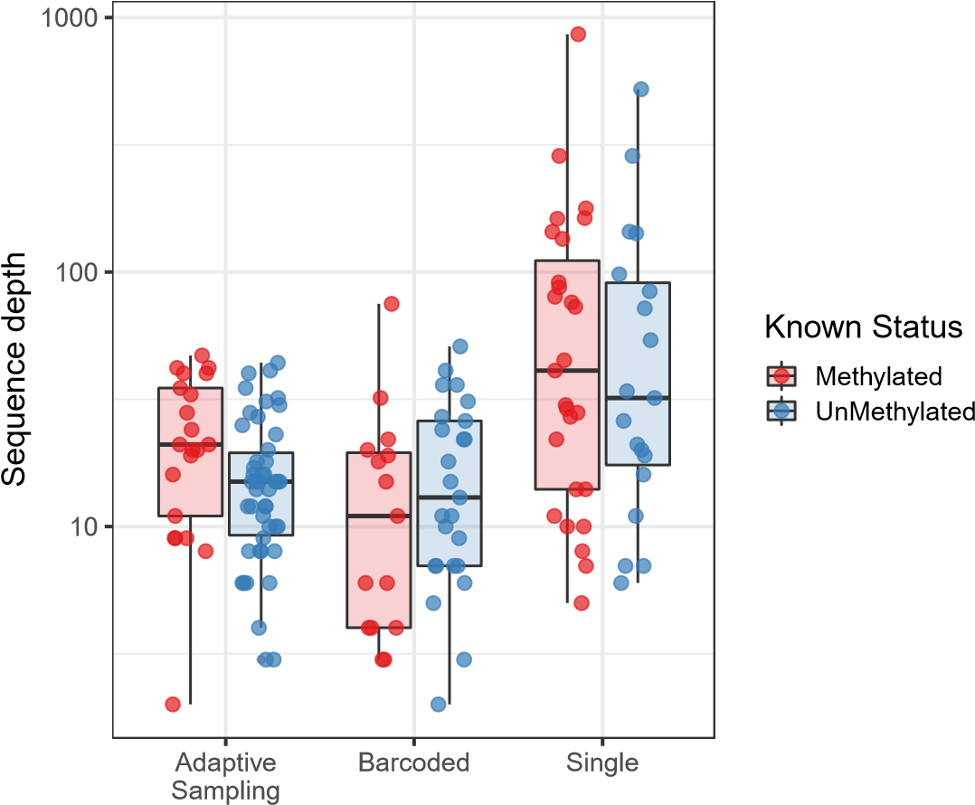

(b)

Figure 1: Overview of samples and sequence depth. (a) Classification of all samples used in this study, separated by known methylation status (b) Methylated versus unmethylated samples by method of acquisition (Adaptive sampling, multiplexed nCats, single sample nCats). No bias in sequence depth was observed between methylated and unmethylated samples but single sample runs generally have higher sequence depth than barcoded samples or adaptive sampling.

2